CMP6200/DIG6200
Individual Undergraduate Project (FYP)
Final Progress Review
The project for learning Chinese and other languages

Student Name: Shu Wang
Student ID: 23153653
Course: BSc (Hons) Computer gaming technology
Supervisor: Richard Davies
Reporting Period: 03/11/2025 to 27/02/2026

1.0 Progress to Date - Summary
This project has been into Model Development and System merge period. Compared to last report, the core mission had changed to merge the AI model and optimize system. Now, the core module of speech recognition had almost ready to merge to application. Also, the project had finished from voice to word processing based on Whisper.cpp by using the offline Chinese speech-to-text function. Now system can load ‘ggml’ module and handle the basic speech reasoning processing.
The main tasks completed in this phase included: building the CMake build system, resolving Visual Studio compilation errors (such as standard library compatibility issues), debugging model loading logic, testing GPU acceleration options (including flash attention configuration), and initially building the user interface structure. Simultaneously, a systematic investigation and fix were performed on path management and dependency library linking issues in the Windows environment, but these have not yet been tested on mobile devices. Additionally, the packaging functionality based on Linux systems still requires acceleration and fixes.
Currently, the project has a working prototype. The most important task is the successful transformation of the theoretical design into a locally run practical system, and the verification of the feasibility of the offline speech recognition solution on personal devices. This lays the technical foundation for the subsequent development of a vocal feedback mechanism.
2.0 Artefact Design and Development
2.1 Implementation and Current State
Regarding the core model: The system implements offline automatic speech recognition based on whisper.cpp. The model is loaded in ggml format, and GPU acceleration can be enabled or disabled depending on the device.
This module has implemented:
• Local model loading
• Inference parameter control
• Basic speech-to-text output
Through testing and verification, the system can stably complete phrase-level Chinese speech recognition.
Regarding system and technology integration: The project uses CMake for build management, integrating whisper and ggml source code. Several key issues were encountered and resolved during development, including:
• std::clamp error (caused by inconsistent compilation standard versions)
• Windows path reading exception
• GPU backend configuration conflict issue
By adjusting the compiler standard, modifying the code structure, and optimizing build parameters, system stability has been significantly improved.
Regarding the UI: The basic interface framework has been built, implementing the following functions:
• Model loading button
• Recording start and stop control
• Real-time transcription text display
• Reserved result feedback area
Although the current interface is still mainly for functional verification and the visual design has not yet been optimized, the functional logic is basically complete.
2.2 Analysis and Reflection
During this phase of development, I gained a deeper understanding of the complexities of offline AI model deployment and system integration. Initially, it seemed that speech recognition primarily relied on the model's capabilities, but in practice, the real challenges lay in engineering-level integration issues, such as memory management, compiler compatibility, and hardware acceleration support.
Secondly, in initial testing, I discovered that simply providing speech-to-text transcription was insufficient for pronunciation learning. While recognition accuracy is important, learners need clear indications of "where the errors are." Therefore, I began to rethink the project's core objectives, gradually shifting the system from a "speech recognition tool" to a "pronunciation feedback system." Future development will include deeper syllable comparison analysis and error highlighting mechanisms to enhance its educational value.
Furthermore, significant stability differences were observed between different devices during GPU acceleration testing. While enabling the GPU significantly improves inference speed, it can cause operational anomalies in certain environments. Therefore, I adjusted the system architecture to make key parameters configurable, thereby improving the system's adaptability and compatibility.
Overall, this phase of practice not only improved the system's completeness but also deepened my understanding of the following issues:
• The practical challenges of deploying large offline models
• Performance trade-offs in real-time inference systems
• The gap between technical functionality and educational value. The project has gradually shifted from the "technical implementation" phase to the "educational application design" phase, and the research direction has become clearer.
Additionally, I also considered adding some gamification elements, specifically whether to include a very simple mini-game played using basic functions like pronunciation. The specifics still require further development, but the technical aspects are relatively simple.
3.0 Updated Planning for Project Completion
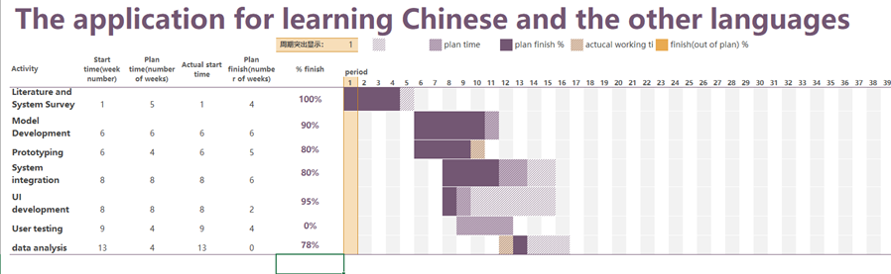
Figure 1: The gant table for this project.
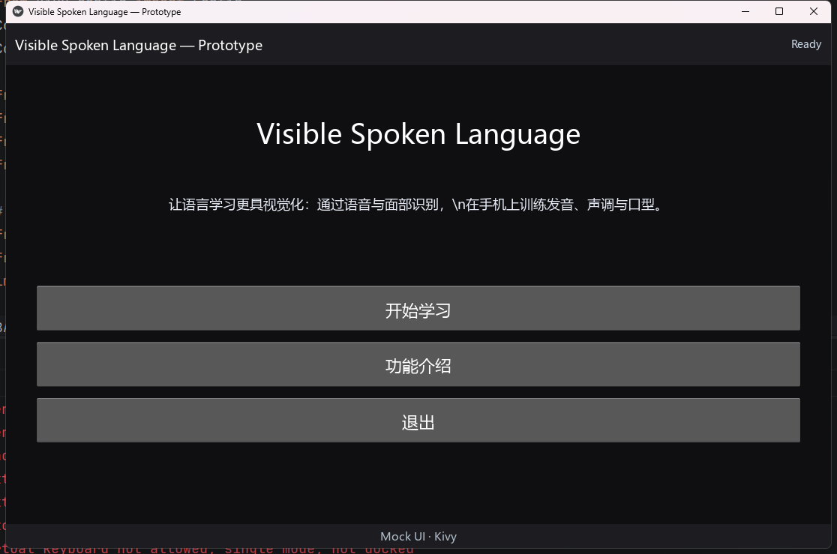
Figure 2: The Main UI of application.
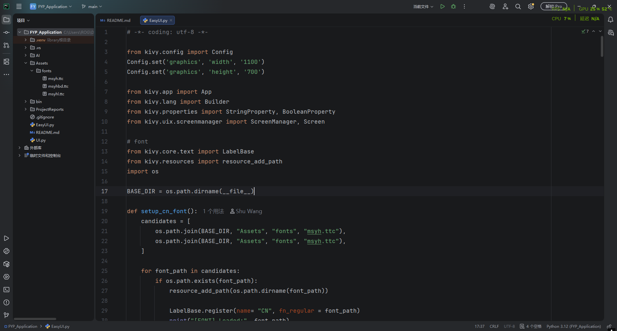
Figure 3: The core UI script of application.
To ensure the project is completed on time and to a high standard, the following tasks will be prioritized:

1.evelopment of a pronunciation feedback mechanism: Design a phoneme comparison algorithm or similarity scoring system to convert the transcription results into structured feedback information.
2.Performance optimization and stress testing: Conduct performance benchmark tests under different hardware conditions to optimize inference speed and stability.
3.ser testing: Invite 5–10 test users to conduct functional and usability tests and collect feedback data.
4.per writing:
• Complete the methodology chapter
• Write the results analysis
• Complete the discussion and conclusion section
• Supplement system limitations and future improvement directions
Priority explanation: The pronunciation feedback mechanism is the core value of the project. If this function cannot be implemented, the system will only remain at the speech transcription level. Therefore, this part is the highest priority task.
3.2 Draft Outline of Final Report
Chapter 1 Introduction
• Research Background
• Research Questions and Objectives
• Project Significance

Chapter 2 Literature Review
• Transformer and Whisper Models
• Computer-Aided Language Learning
• Offline AI System Deployment Challenges

Chapter 3 System Design
• Overall Architecture
• Model Integration Scheme
• UI Design Logic

Chapter 4 System Implementation
• CMake Build Process
• Model Loading Mechanism
• Parameter Optimization Process
• Debugging and Problem Solving

Chapter 5 Testing and Evaluation
• Performance Testing
• Accuracy Testing
• User Feedback Analysis

Chapter 6 Discussion
• Technical Significance
• Educational Application Value
• Limitations

Chapter 7 Conclusion and Future Prospects

